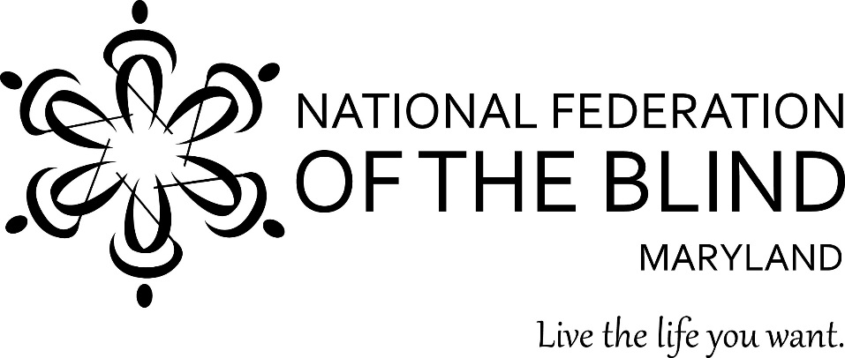
Subject: Appropriation for the Center of Excellence in Nonvisual Access (CENA) to Education, Public Information, and Commerce

To: Members of the Maryland General Assembly
From: Members of the National Federation of the Blind of Maryland

Contact: Sharon Maneki, Director of Legislation and Advocacy

National Federation of the Blind of Maryland
9013 Nelson Way
Columbia, MD 21045
Phone: 410-715-9596
Email: nfbmd@earthlink.net

Date: January 16, 2020
PROPOSED ACTION
The Maryland General Assembly should keep the $250,000 appropriation in the Governor’s Budget for the CENA to Education, Public Information, and Commerce.

BACKGROUND
In 2014, the National Federation of the Blind (NFB) founded the NFB Center of Excellence in Nonvisual Access (CENA). The CENA is a center of expertise, best practices, and resources that enables business, government, and educational institutions to more effectively provide accessible information and services to blind citizens. The State of Maryland, through the Maryland Department of Disabilities (MDOD), partners with the CENA to support a series of projects under the Nonvisual Accessibility Initiative (NVAI) with an aim to establish Maryland as a leader in nonvisual accessibility.

Accessible Maryland Job Centers
The US Department of Labor's final report, “Evaluating the Accessibility of American Job Centers for People with Disabilities,” states that “almost two-thirds (63 percent) of American Job Centers (AJCs) were not accessible.” With over 70 percent unemployment of people with disabilities, the ensuring accessibility of these job centers is essential. The NFB will conduct assessments of Maryland job centers and work to make them fully accessible to job seekers with disabilities.

A More Accessible Maryland
In addition to the emerging nonvisual access navigation or wayfinding technologies that offer orientation and information solutions to a variety of public and commercial venues, there are innovative technologies being developed and implemented that create more accessible experiences for people with disabilities to live, work, and play in their communities. The NFB has been involved in the evaluation and development of a variety of cutting-edge wayfinding and other environmental information technologies. Through our Accessible Cities projects, we can enhance MDOD’s Access Maryland efforts and create a more accessible Maryland.

Inclusive Publishing Conference
The Inclusive Publishing Conference will tie in with the CENA’s focus on access to digital publications, and will have sessions that address accessible publications in educational arenas as well as for the general population.

Enhanced Accessible Academic EBook Program
The HathiTrust is a consortium of institutions offering more than thirteen million titles digitized from around the world. The resulting accessible electronic text continues to change the way blind people access information, especially in academic environments. Electronic text is encoded text that can be interpreted by a machine, and therefore can be presented to any user in whatever way they would find most helpful. It can appear as printed letters on a screen (at any size), be spoken aloud by synthetic text-to-speech voices, or rendered on a refreshable Braille display. The NFB will build on the information offered through the HathiTrust Digital Consortium by assisting in the development and implementation of other accessible electronic book platforms.

Accessibility Boutiques and Training Seminars
The NVAI has contributed to a number of informal accessibility-specific boutiques and training seminars. The boutiques are several hours long and are open to the public at no cost to Maryland citizens. The larger training seminars are more intensive and can take place over several days. The intended impact is to increase accessibility awareness and the knowledge of educators, government administrators, businesses, and others about the tools and training they can use to better provide nonvisual access to their programs and services.

Accessibility Switchboard
The Accessibility Switchboard is a dynamic online accessibility portal that provides up-to-date information to consumers about accessible websites, emerging technology, and frequently encountered accessibility problems/solutions; and also provides information specific to government, corporate, and educational institutions on building accessible websites. The NFB will continue the development of this resource.

Accessibility Inclusion Fellowships
The “Final Report of the Study on Accessibility Concepts in Computer Science, Information Systems and Information Technology Programs in Higher Education,” was submitted to the governor and to the General Assembly in August 2017. The report recommended that three annual fellowships be awarded to instructors that include accessibility concepts within at least one course in their institution. The NFB will administer and coordinate the third year of the Accessibility Inclusion Fellowship program.

Conclusion
Access to information remains one of the greatest barriers faced by blind persons. To reduce these barriers the National Federation of the Blind established the CENA to provide information about best practices and to develop innovative techniques for achieving nonvisual access. The Maryland General Assembly should allow this state-of-the-art program to continue by approving the $250,000 appropriation in the Governor’s Budget under the Maryland Department of Disabilities.

