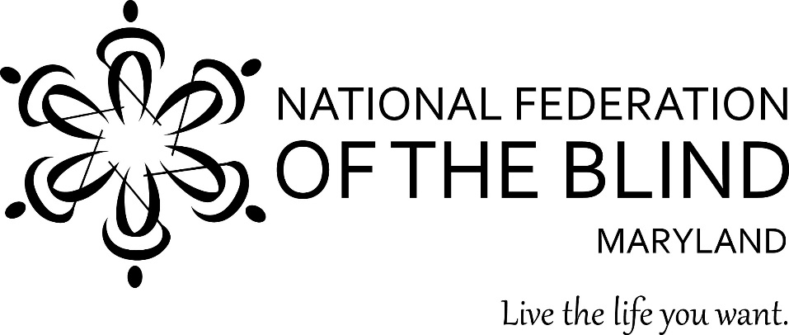

Subject: Uplifting the Maryland Library for the Blind and Physically Handicapped into the 21st Century
To: Members of the Maryland General Assembly
From: Members of the National Federation of the Blind of Maryland
Contact: Sharon Maneki, Director of Legislation and Advocacy
National Federation of the Blind of Maryland
9013 Nelson Way
Columbia, MD 21045
Phone: 410-715-9596
Email: nfbmd@earthlink.net

Date: January 16, 2020

THE PROBLEM
The Maryland Library for the Blind and Physically Handicapped (LBPH) provides books, magazines, and newspapers in Braille or audio formats to citizens who cannot read regular print. Many people who need this service are reluctant to use LBPH because they do not regard themselves as being physically handicapped. This is especially true of seniors losing their vision, a rapidly increasing segment of the population.
In 2016, the Maryland General Assembly and Governor Hogan created the Maryland State Library Agency (MSLA) and established the Maryland State Library Board (MSLB) to oversee the MSLA. The MSLB consists of seven members appointed by the Governor and five ex officio members from government and library entities. There is no provision in this law to ensure that one of its members represents the interests of LBPH. Since 22 of the 29 staff members of MSLA work directly for LBPH and a large portion of the State Library budget is used for LBPH services, a knowledgeable blind person should always be designated as a member of this board to ensure that the specialized needs of LBPH are supported.
PROPOSED ACTION
1.) The Maryland General Assembly should enact legislation to change the name of the Maryland Library for the Blind and Physically Handicapped (LBPH) to the Maryland Library for the Blind and Print Disabled (LBPD).
2.) In order to guarantee that the specialized needs of the proposed LBPD are recognized and met, this legislation should also require the membership of a knowledgeable blind person on MSLB at all times.
BACKGROUND
The LBPH is part of a national network of cooperating regional libraries under the jurisdiction of the National Library Service for the Blind and Print Disabled (NLS), Library of Congress. NLS provides books and magazines to LBPH while the State of Maryland provides the staff and the facility that houses LBPH. The NLS was formerly known as the National Library Service for the Blind and Physically Handicapped. Its name was changed to the National Library Service for the Blind and Print Disabled on October 1st, 2019.
The LBPH has been in existence for 52 years. Patrons must prove that they are blind or physically handicapped in order to use LBPH’s services. However, the term “physically handicapped” has a specific meaning. It means that a person cannot read a book because they are physically unable to hold it or to turn its pages. Therefore, the term “physically handicapped” is confusing to public officials as well as the general public. In keeping with the name change of its parent organization, and to emphasize its true mission, the proposed name change to LBPD should be enacted.
In order to provide books and magazines in specialized formats, the copyright laws required all libraries for the blind to request special permission from publishers. Over the years, copyright law has become less restrictive. In 1996, Congress passed the Chafee Amendment, which reads in part:
“it is not an infringement of copyright for an authorized entity to reproduce or to distribute in the United States copies or phonorecords of a previously published literary work or of a previously published musical work that has been fixed in the form of text or notation if such copies or phonorecords are reproduced or distributed in accessible formats exclusively for use by eligible persons.”
The copyright permission was further expanded by the creation of the Marrakesh Treaty in 2013 which the United States ratified in 2018. The goal of the Treaty is to help to end the book famine faced by people who are blind, visually impaired or otherwise print disabled. Currently only 1 to 7 percent of the world’s published books ever make it into accessible formats. This is partly due to access barriers in copyright law – a barrier which the treaty helps to remove. Libraries for the blind no longer have to seek special permission from publishers when they convert materials into specialized formats. The Marrakesh Treaty is revolutionary because it permits the exchange of books in specialized formats between participating countries. This treaty uses the term blind and print disabled when describing the category of people entitled to use these specialized formats. In keeping with the language of the Marrakesh Treaty, it is absolutely critical for the State of Maryland to adopt the name change to its library for the blind to LBPD.
In 2016, legislation was enacted to reorganize the governance of Maryland’s libraries in the structure of state government. This legislation removed state libraries from the jurisdiction of the Maryland State Department of Education and placed Maryland’s library function in a separate agency called The Maryland State Library Agency (MSLA). This law also created the Maryland State Library Board (MSLB) to oversee the MSLA. Due to an oversight, the law made no provision to protect the prominent role of LBPH in the MSLA. The required inclusion of a knowledgeable blind person on the MSLB will provide for the maintenance of LBPD’s quality services and proper role in the management of the MSLA.
ADVANTAGES OF THE PROPOSED LEGISLATION
Removing the archaic and offensive term, “Physically Handicapped”, and replacing it with the appropriate term “Print Disabled”, will improve the marketing of library services. More people will understand the function of the LBPD and take advantage of its collections and services. In today’s society, the term “handicapped” has a negative connotation. The term “print disabled” indicates that a person’s disability pertains only to reading.
The proposed name change will not require much additional funding. The mission of the library remains the same. It exists to help individuals obtain access to reading materials. The population who use the LBPD also remains the same.
Libraries for the blind have specialized services because they distribute materials in Braille and audio formats. Members of the MSLB do not have the knowledge or expertise to advise the MSLA on matters relating to these specialized needs. It is necessary for a knowledgeable blind person to always be designated as a member of this important board.
CONCLUSION
Literacy is a critical life skill. Blind and visually impaired citizens in Maryland are literate because LBPH provides them with accessible materials. Changing the name to LBPD will eliminate confusion about its mission. Eliminating the archaic term “ physically handicapped” will encourage greater use of the LBPD. This name change will also bring it into compliance with federal law and with the Marrakesh Treaty. The requirement to include a knowledgeable blind person as one of the seven members appointed by the governor will improve the effectiveness of the MSLB to carry out its responsibility of advising the MSLA. The members of the National Federation of the Blind of Maryland urge the Maryland General Assembly to change the law as outlined above to improve services provided to the blind and print disabled citizens of Maryland.

